Near Optimal Multiple Sequence Alignments Using a Traveling Salesman Problem Approach

Chantal Korostensky and Gaston Gonnet
String Processing and Information Retrieval Symposium, 1999 and International Workshop on Groupware , 1999 , Page(s): 105 -114

Abstract
Our algorithm can calculate a near optimal MSA and has a performance guarantee of 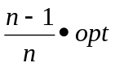 (where opt is the optimal score of the MSA). The algorithm runs in O(k² n²) time.
- Introduction
- Algorithm
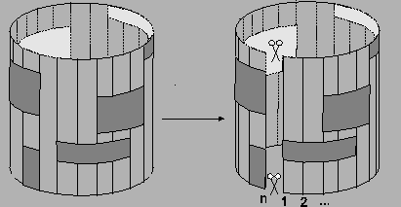
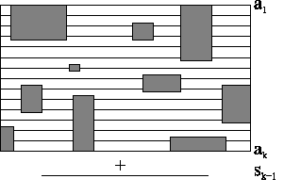
Sequences <a₁, …a_{k}>are aligned and build an MSA A’ with optimal partial score

Step1
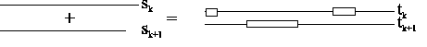
Step2 and Step3
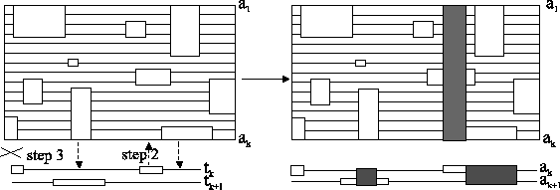
- Further Improvement
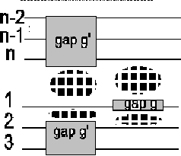
Insertion of gap g in sequence a₁ or a_{n} results in an insertion of gaps in all other sequences. The score of the MSA is affected at four places .

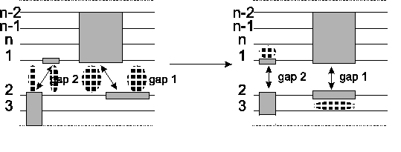
Before the optimization there are four border blocks. After shifting, two optimal alignments are disturbed a bit, but in exchange two gap blocks are gone.
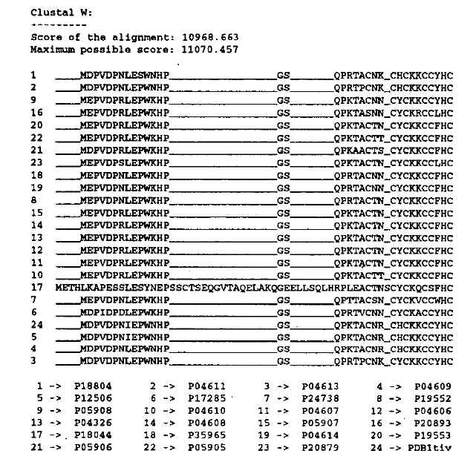
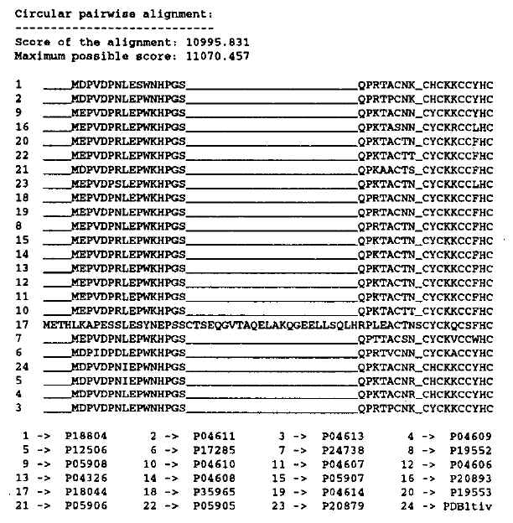
Created by: Kuen-Feng Huang
Date : Oct. 17,2000

